UNIX Project
Report

Đoàn Phan Quốc Bảo – USTHBI5-017
Phạm Tiến Thành - USTHBI5-123

1, Requirements:

Part 1: Project4: Write a program with the following feature
1. List all the video files from a folder (including sub-folders)
2. Sort files by file name, file size, created date
3. Detect and highlight all the video file that have the same name (possible
redundancy)
4. Play a video by clicking on the video path
5. Search video files by keyword
The Graphical User Interface is written in C/C++
All commands are written in Shell Script.

Part 2: Project3: File transfer application which can handle one request at a time. Transfer
History is store in a database

Work division: part 1 : Bảo --- part 2 : Thành

2, Achieved products:

Part 1:

- User Interface screenshot:

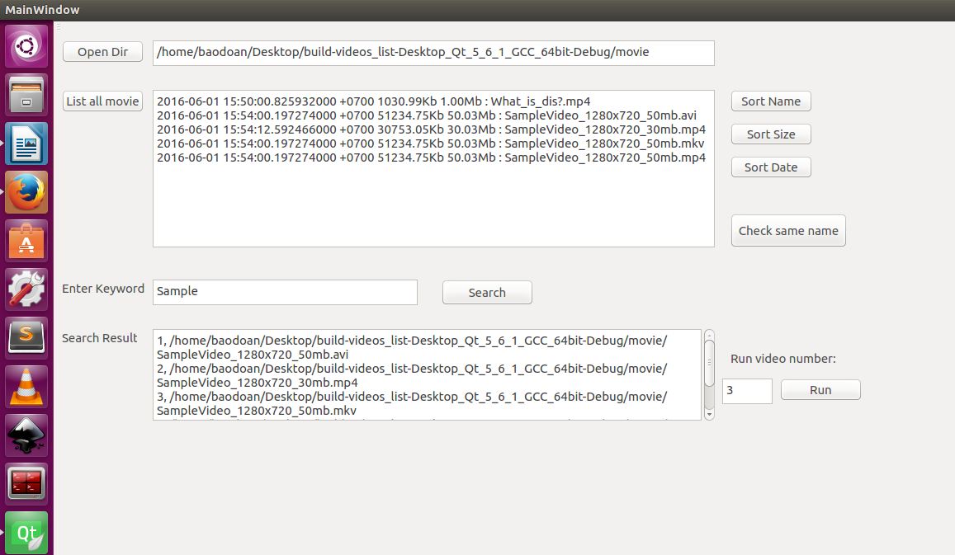

- Code for User Interface:

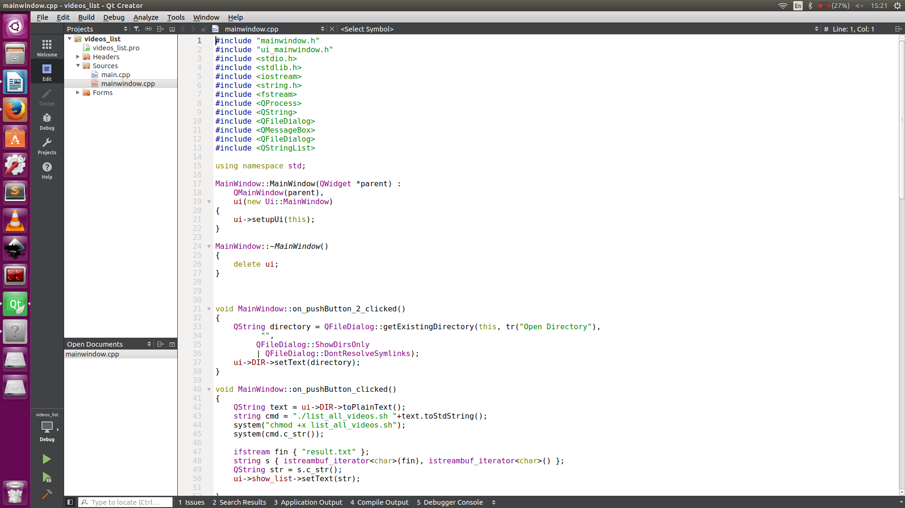

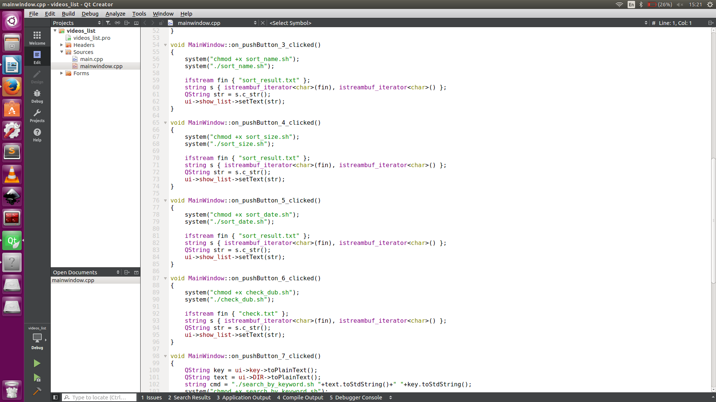

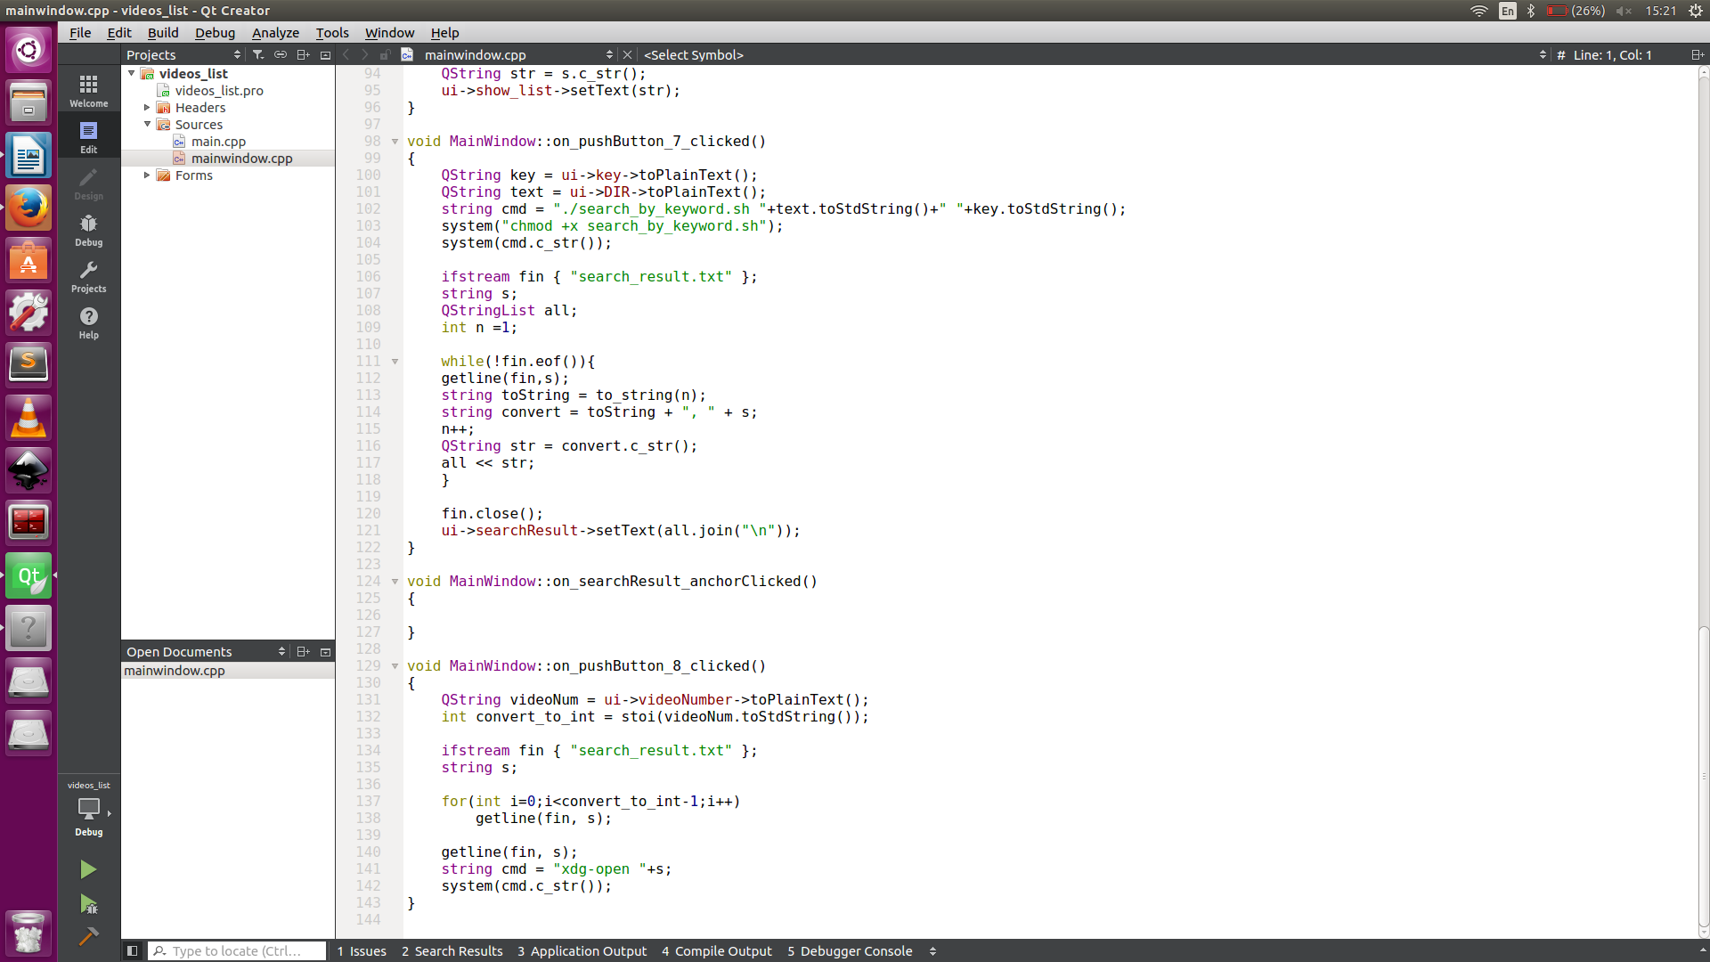
- Bash script:

+ List all video in folder and subfolder:

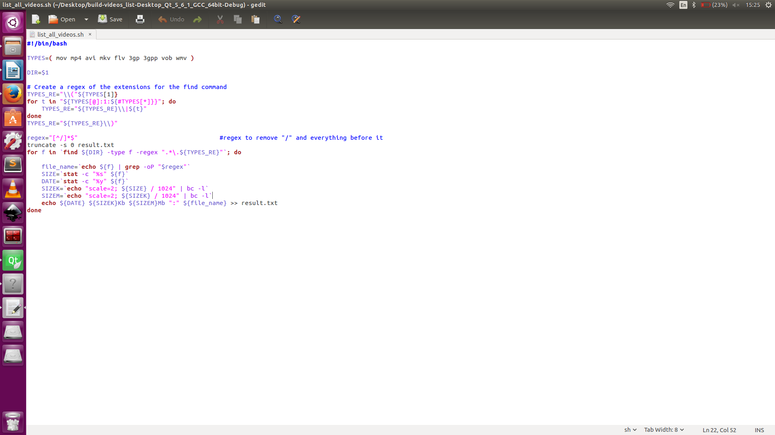

+ Sort by name, size and date:

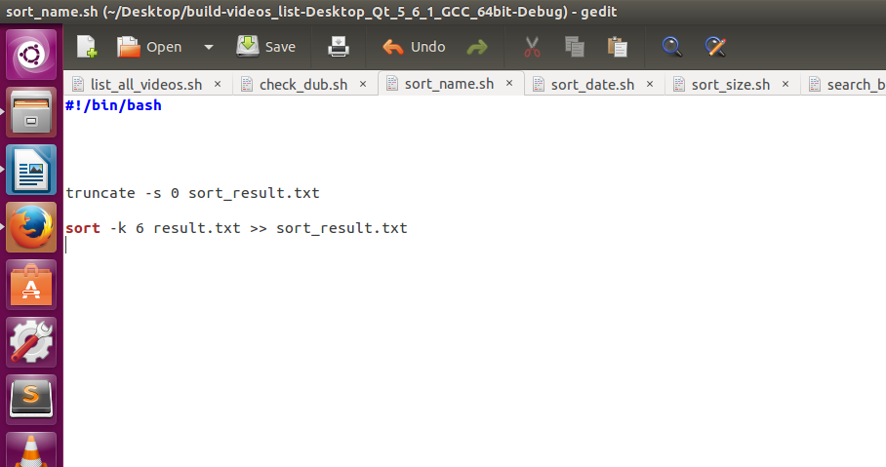

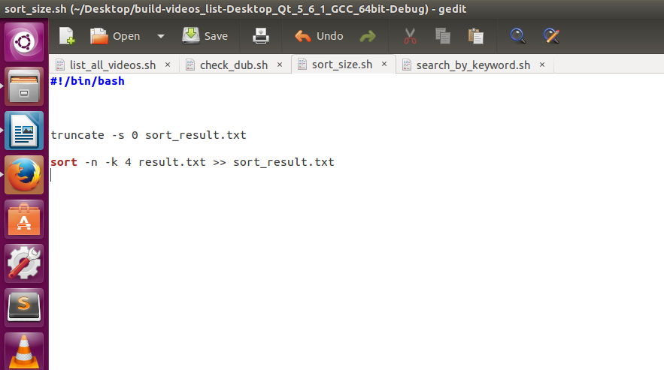

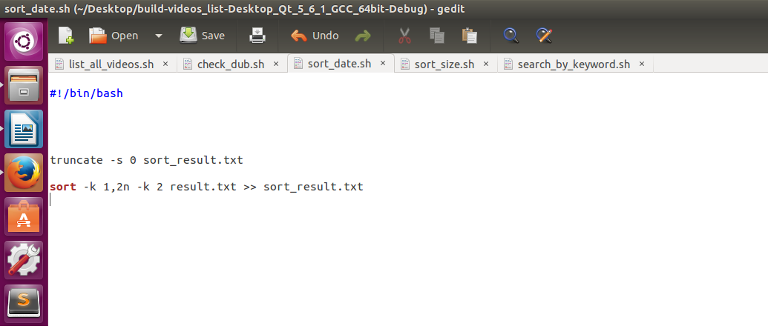

+ Check duplicated file name:

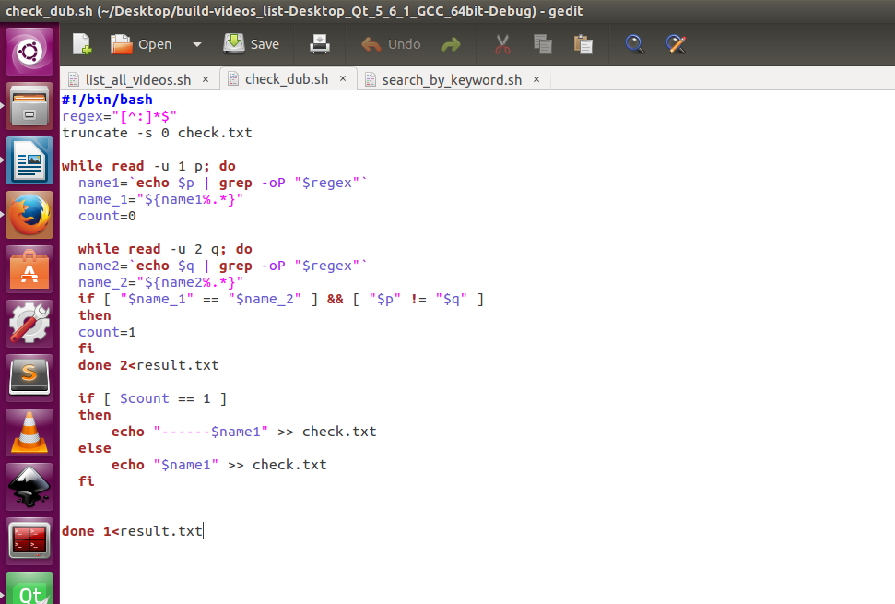

+ Search video file by keyword:

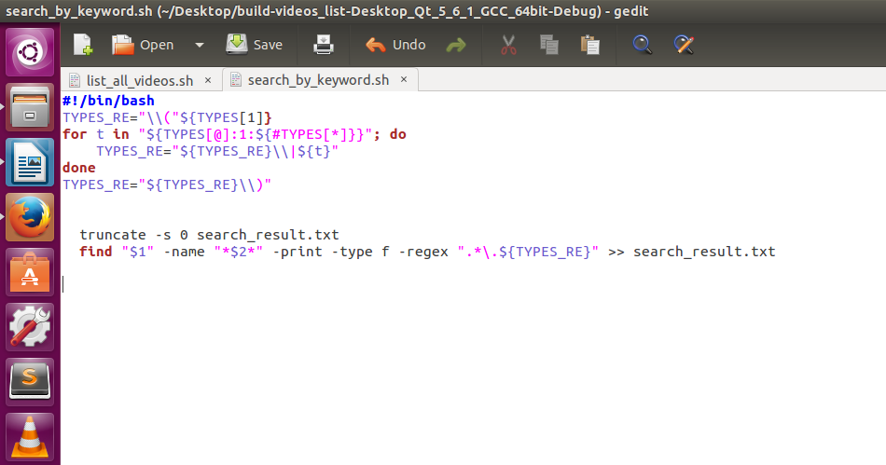

Part 2:

- User Interface:

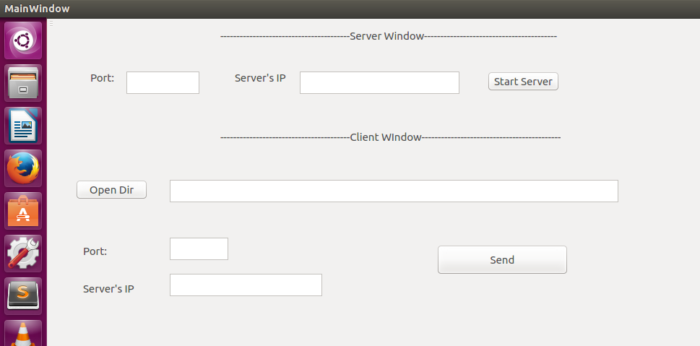

- User Interface's code:

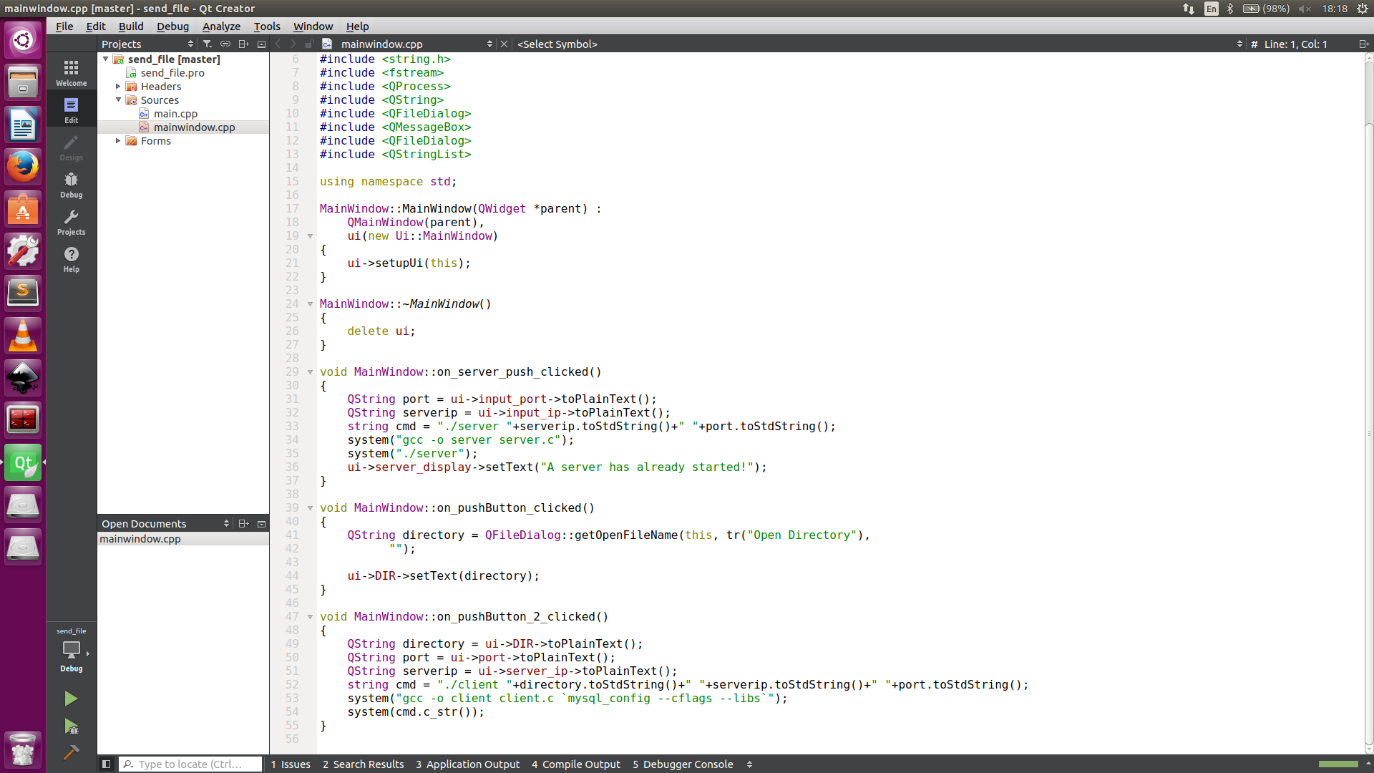
- C Socket code:

+ Server:

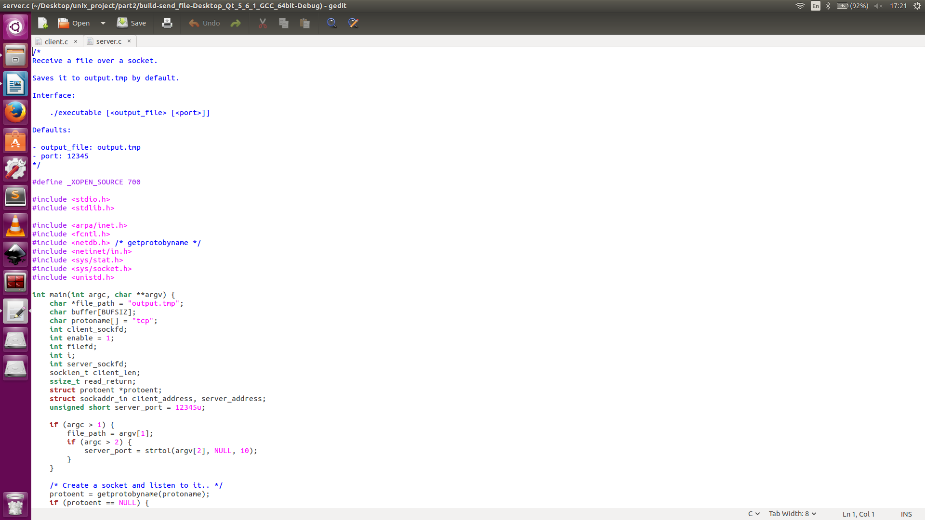

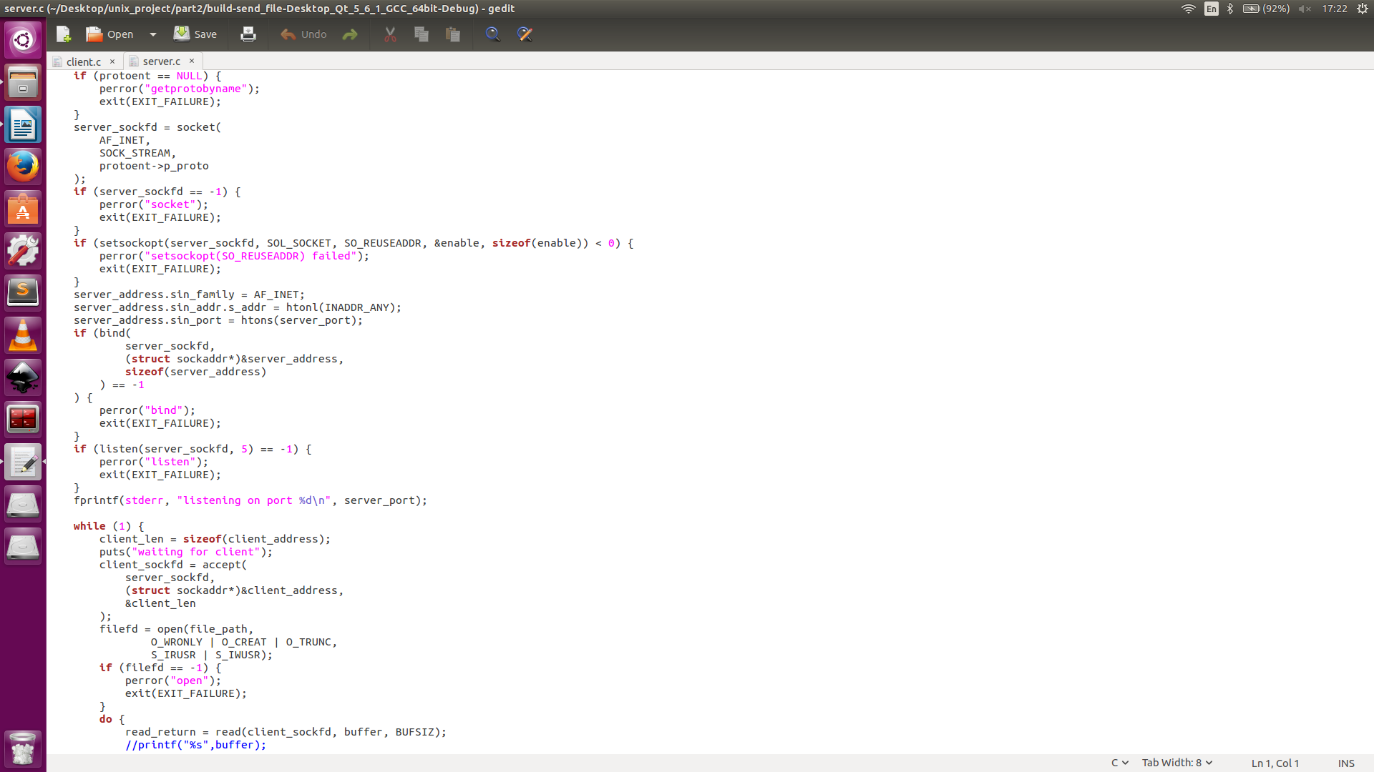
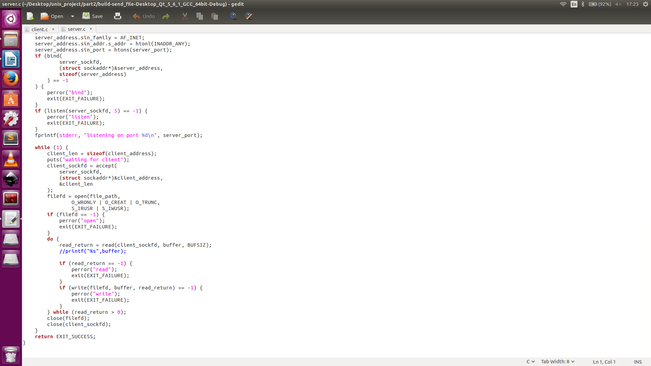

+ Client:
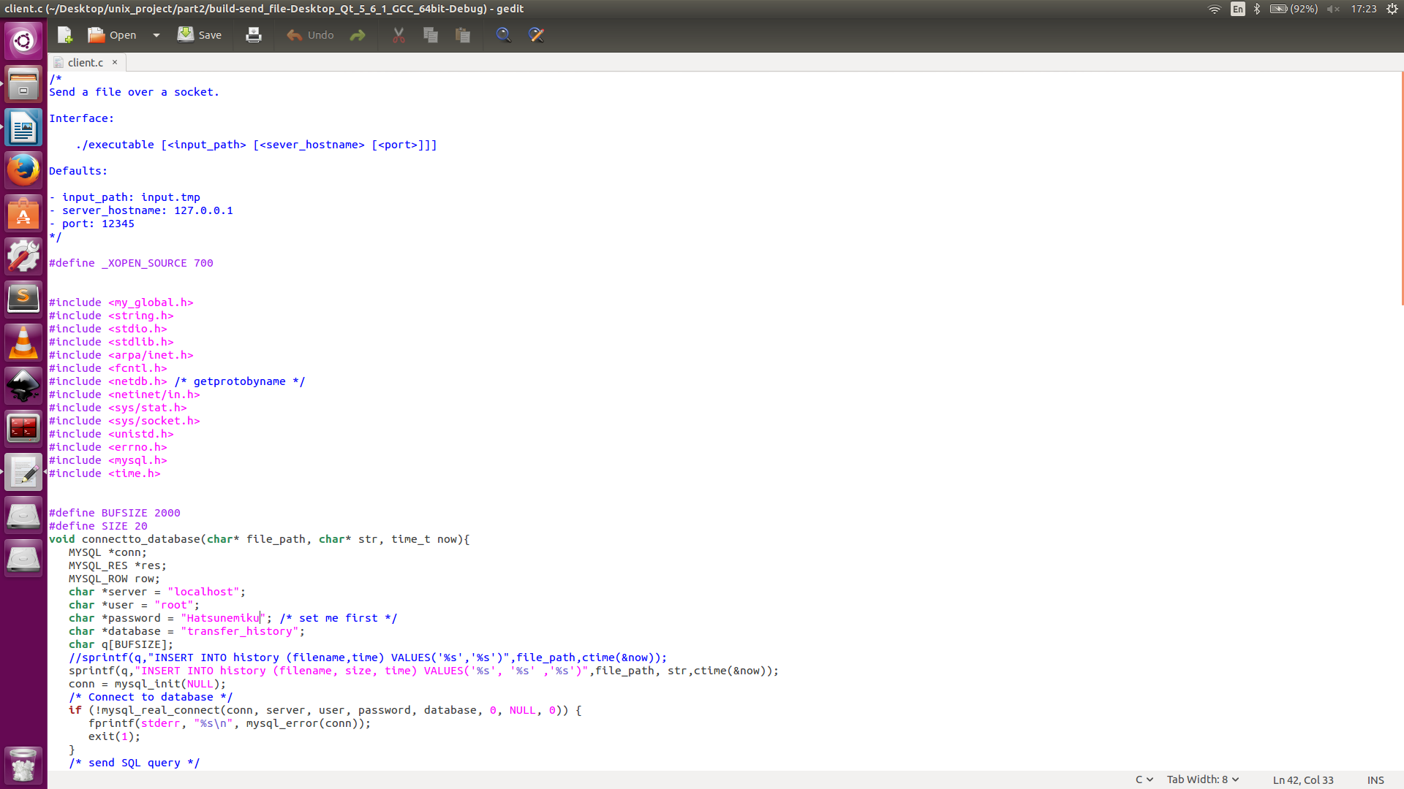
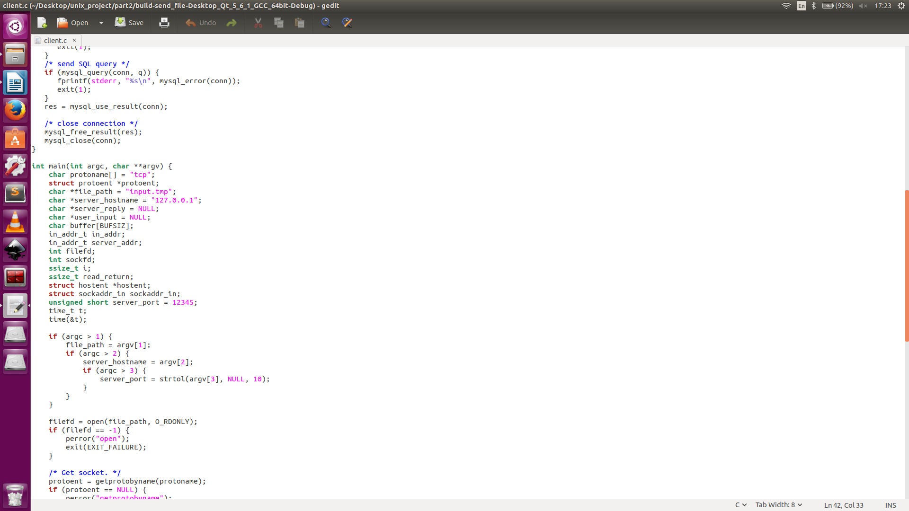

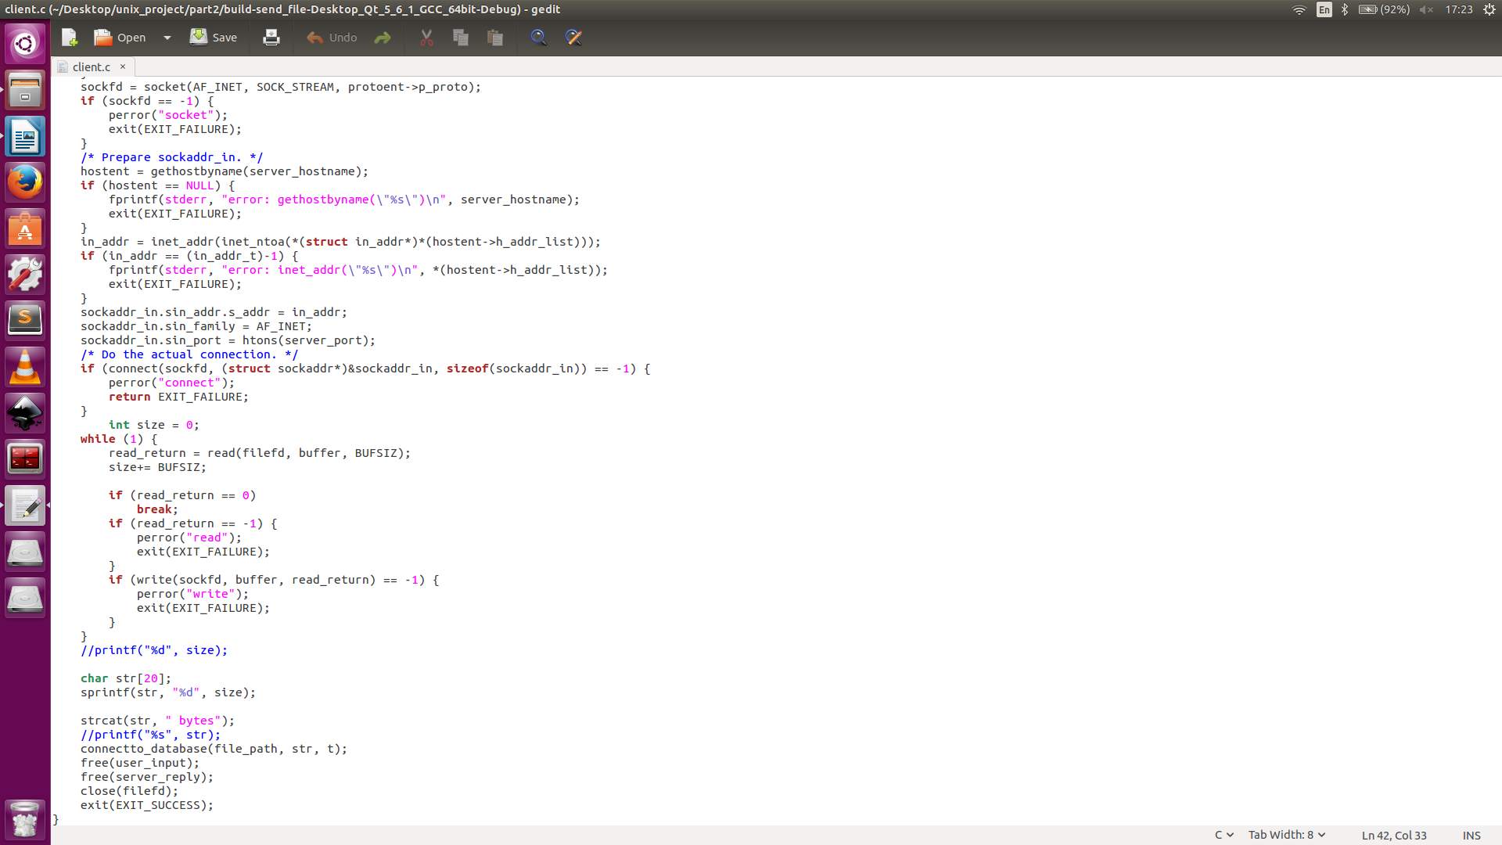

3, Conclusion.

- By doing this project, we have learnt how to make UI with Qt, how to do CSocket programming and to link to database. Also, we have improved skills of programming with Bash Script, C++, C and mySQL.

- Problems encountered:
+ Having problem with click-to-run function in part 1, which allow user to play the video when clicking the video's path. I don't know how to make each path clickable and execute function when clicked, so I have to do it in a different way.
+ Problem understanding all syntaxs of regular expression.

4, Assisted tools.
- Version control: github
Part 1: https://github.com/baodoanusth/part1
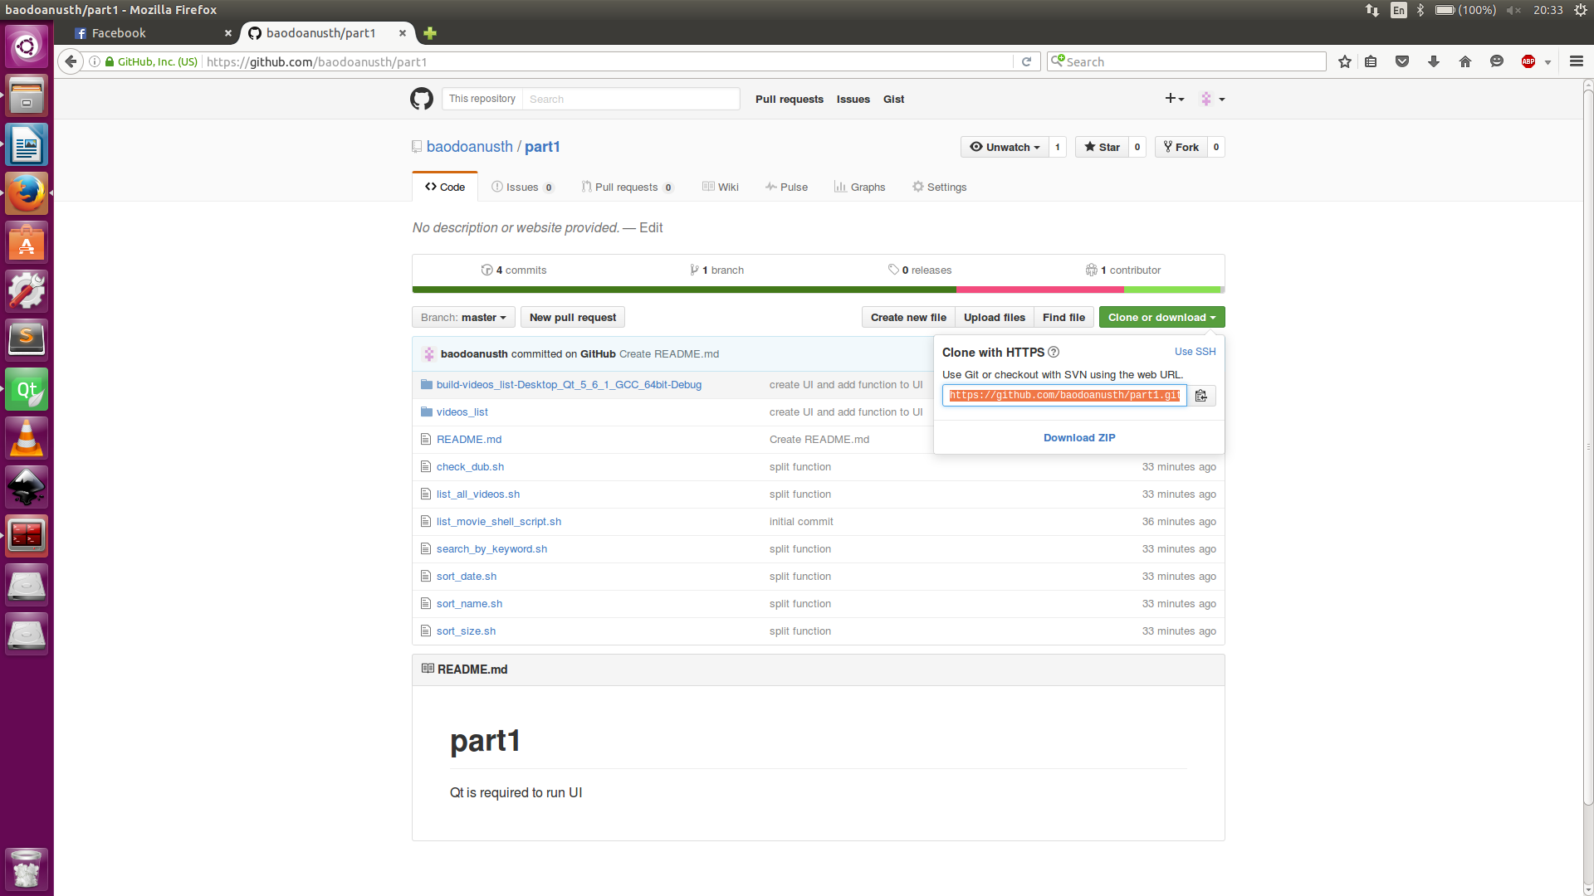

Part 2 : https://github.com/vicnoob/part2

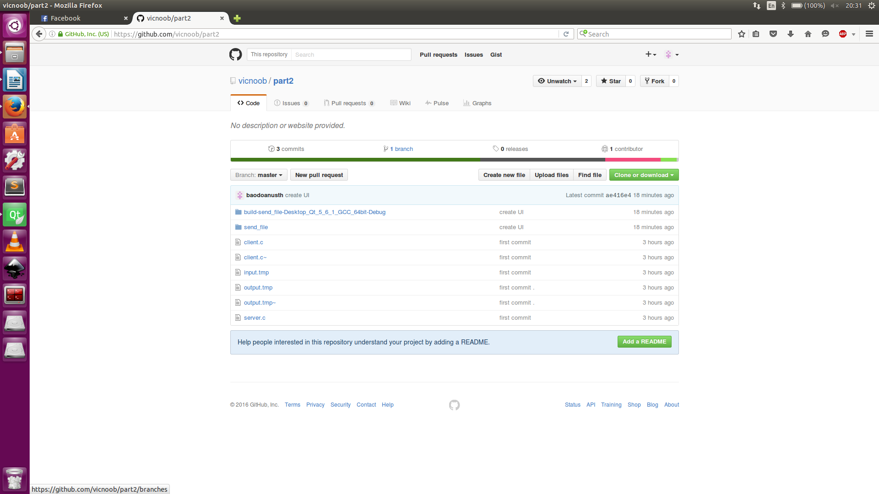

- Makefile:

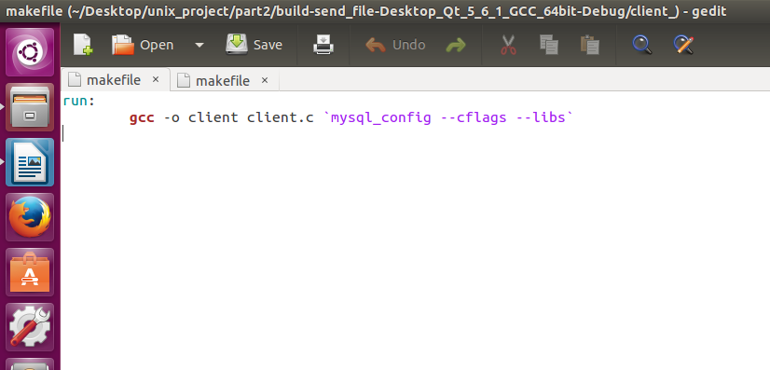

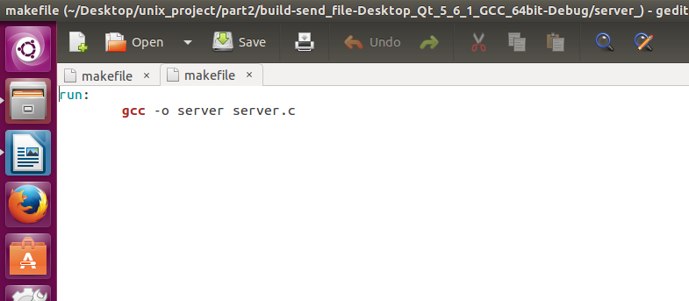

- Qt


